PROJECT PROFILE
Project Title | Employee Management System
Project Description | This project of mine works like add delete employee, how to update their information, how to find employee from database etc.
Front End | Core java
Back End | MySQL
Other Tools | Apache NetBeans IDE18
Guide | Mr. Ripal V. Pandya
Submitted To | S.S.S.D.I.I.T College

USE OF SYSTEM DEVELOPMENT LIFE CYCLE MODEL
Software Development Life Cycle (SDLC) is a process for development of software. There are some steps to follow to create a software application.
In an SDLC the steps follows requirement gathering. In requirement gathering questionnaire, personal interview etc. are the method for gathering information. Analysis phase includes creating Software Requirement Specification and analyze the gathered data. In design phase, design of Software application i.e. database design and GUI design have to be prepared. In coding phase, coding is done of different modules and forms. In testing phase, the different type of testing is done like integration testing, unit testing, system testing and at last the created software is implemented and maintained.
Following are the different Life Cycle Model example.
• Waterfall model
• Iterative waterfall model
• Prototyping model
• Evolutionary model
• Spiral model
• R.A.D. model (Rapid Application Development)

Waterfall model:-
In this project I have used the Waterfall model. waterfall modalworks well for smaller and low budget projects where requirements are very well understood. Clearly defined stages and well understood. It is easy to arrange tasks. Process and results are well documented.
The waterfall model is the first model in software development history. It is also referred to as the (Linear sequential life cycle model) this model is simple to understand and use. In the waterfall model, each phase is completed before moving to the next phase. The waterfall model is the first and earliest approach used in SDLC for the development of software products in this model that do not overlap. Waterfall Model Design The waterfall approach was the first approach in the software development life cycle and was widely used in the development of software products and for the success of the project. Requirement Analysis System Design Implementation Testing Deployment Maintenance The sequential phases of waterfall model. Requirement Analysis. All the key requirements of the system development and captured in this phase and we document them in the software requirement specification document.
The waterfall model is most commonly used in software engineering and product development, less often – in other projects and industries. Employ the waterfall model only if your project meets the following criteria .All the requirements are known, clear, and fixed.
The classical waterfall model divides the life cycle into a set of phases. This model considers that one phase can be started after the completion of the previous phase. That is the output of one phase will be the input to the next phase. Thus the development process can be considered as a sequential flow in the waterfall. Here the phases do not overlap with each other.

The diagram of Waterfall Model:
Requirement gathering
System Design
Implementation
Testing
Deployment
Maintenance

FEASIBILITY STUDY
Feasibility of a project determines whether it is possible to develop the project. These are four main factors, which determine the feasibility of the project. They are discussed follow.
- Technical Feasibility Study :-
The main aim of technical feasibility study is to determine whether it is possible to develop the proposed system with the present technologies available and study the technical equipment availability in market.
Feasibility studies are important for projects that represent significant investments for your business. Projects that also have a large potential impact on your presence in the market may also require a feasibility study.
So, in this project technical requirement is:
Hardware: A computer with:
- 2GB RAM
- 1 HardDisk
- Intel Core Processor
Software: A computer with:
- Netbeans
2)operational Feasibility Study:-
The Operational feasibility deals with the matter whether the proposed system fulfils the requirements of the organization. This Feasibility determines whether the proposed system covers all the aspects of the current system and gives an extra facility which is not in current system.
Our Software is easy to understand and easy to operate the design of insert, update or delete the task it’s very easy to understand. So, this project is operationally very much feasible for any person in organization to handle it.
- This Software require the person who handle it by few clicks.
- We can satisfy the whole requirement of the organization.
- Person can save the data of it whenever required.
- Easy to manage by all the persons who can see it or work on it.

- Economical Feasibility Study :-
The economic feasibly takes into consideration the financial matters regarding the purposed system. The organization measures the cost effectiveness of the proposed system; the economic feasibility of the proposed system is as under budget of a company or not! This is checked in economic feasibility.
The economic feasibility analysis is a study that will compare the returns to be obtained with the investment required to point out its feasibility, being, therefore, an extremely important process, which brings business intelligence, avoids losses, and leads to more assertive decisions.
As the requirement there is must be the cost of the following things.
Development Cost: 12000/-
-Design Cost:8000
- Light Bill: 1800/-
- Other Cost: 10200/-

REQUIREMENT GATHERING
1)Give me General Information About Project.
→ Name: Employee Management System
→ Used: It is Used to save Employee Details and Add this Employee in Company
2)Do you have a Running Software?
→No
3)What kind of features do you need in your software?
→I want features like login user, Add Employee details, View Employee details ,Update Employee details, Remove(Delete) Employee, search Employee etc.
4)Do you have any Registered Domain or Hosting?
→No
5) Who are the primary users of the system?
→only for Login users
6) Do you require training for staff on how to use the new system?
→Not required
7) In contact page do you need your office map location?
→No
REQUIREMENT ANALYSIS
Requirement gathering phase of software development life cycle acquires information from the organization for which we are preparing project. There are many techniques to acquire information. It’s simple meaning to get a user’s requirement for website which kind of facility user wants. Following are the techniques for information gathering.

• Questionnaire
• Observation
• Personal Interview
• Record Review

From the above options, I have used “Observations” and “Personal Interview” method for requirement gathering. I have adopted Questionnaires because I can properly understand their need of website. I can also understand about different rights given to different users and the basic about website. By using Personal Interview I have understood the smallest need of their application and some idea of layout and designing.
The main requirements for the site are listed below:
✓ All users can sign in to GEMTRACK Websites.
✓ Admin can add new websites, Category, Sub-Category, Product, SubProduct and reply websites.
✓ Only Admin can delete websites.
✓ Only Admin can perform User Management.
✓ Administrator can delete user and also can change rights of user.
PROJECT ABSTRACTS
User Group:
Administrator
User(Login)

Administrator:
- Admins have full control and management of the System.
- Add, Edit, Delete, update Employee Details
- Monitor and manage user accounts.
- Handle Employee Details.
- Update Employee management System content
- Set Employee

User:
- Add Employee Details.
- View Employee Details
- They Will also Add Employee

PROPOSED SYSTEM
Actual role of this website is to provide the glue between General User and Administrator in the way of
• User Management
• Maintaining Personal Information

The objective of this application is to allow every user to edit and find out the details and Employee details. It also facility store Employee Detais. And it can retrieve within few seconds. Overall, it’ll make way to access all Employee and details by using the USER application.

ADVANTAGES & LIMITATIONS OF PROPOSED SYSTEM

Advantages:
→ Easy access to Employee data with correct Employee history.
→ Data security and correct data retrieval made possible.
→ User search the Employee details and easy to find

Limitations:
→This System Used to only for Desktop and Laptop

PERT CHART AND GANTT CHART

PERT CHART:
PERT (Project Evaluation and Review Technique) charts consist of a network of boxes and arrows. The boxes represent activities and the arrows represent task dependencies. PERT charts are a more sophisticated form of activity chart. Where instead of making a single estimate for each task, pessimistic, likely and optimistic estimates are made. The boxes of PERT charts are usually annotated with the pessimistic, likely, and optimistic estimates for every task. There are thus not one but many critical paths, depending on the permutations of the estimates for each task. This makes analysis of critical path show by using shaded boxes. The PERT chart representation of the MIS problem of show follows.

Finish
Design GUI Part
Code GUI Part
Integrate & Test
Design Database Part
Specification

Documentation
Code Database Part
5 July – 10 July
11 July –10Aug
10 Aug – 05 Oct
11 Aug-05Oct
11 Aug – 05 Oct
05 Sep – 05 Oct
07 Oct
05 July – 07 Oct

Gantt chart can be derived automatically from PERT charts. However, PERT charts cannot be automatically derived from Gantt charts because PERT charts incorporate additional information about the time when an engineer doses a task. This information is not available is helpful in planning the utilization of resources, while the PERT charts is more useful for monitoring the timely progress of activities. Also, parallel activities in a project can be easily identified using a PERT chart.

GANTT CHART:
Gantt charts are mainly use of scheduling, budgeting, and resource planning. It allocates resource to activity include Staff, Hardware, Software, etc…
A Gantt chart is a special type of bar chart where each bar represents an activity. The bars are drawn along a time line. The length of each bar is proportional to the duration of time planned for the corresponding activity.

Gantt charts used in software project management are actually an enhanced version of the software project management. Each bar consists of a white part and a shaded part. The white part of the bar shows the length of time each task is estimated to take.
The shaded part of the bar shows the slack time. In order to estimate the time durations for various activities, usually managers let the engineers themselves estimate the time for an activity they might be assigned to.
However, some managers prefer to estimate the time for various activities themselves. Many managers believe that an aggressive schedule motivates the engineers to do a job better and faster. However, careful aspects, but also cause schedule compromise on intangible quality aspects, but also cdkause schedule delays. A good way to achieve accuracy without creating problems is to let people set their own schedules.
We can see that one engineer can do the database design and then code the database design whereas another engineer and design the GUI part, code the GUI part, and still have time left for writing the user manual. Thus, Gantt charts are very useful in scheduling resources.
So here, I have to follow the scheduling steps for my project.
Gantt chart is really useful us dkfor planning software application resources.
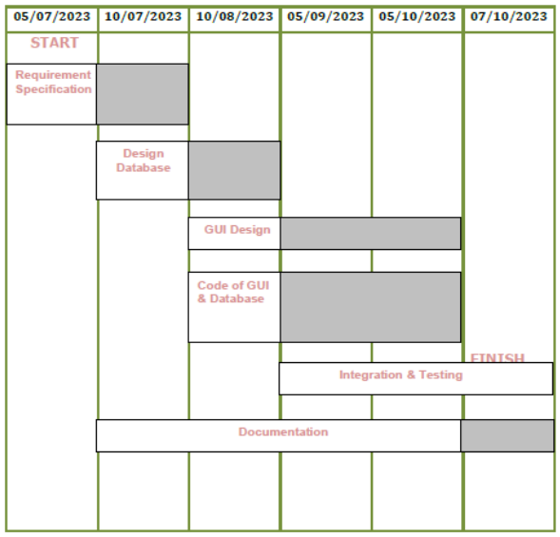

DATA FLOW DIAGRAM

Detailed Life Cycle of Project:
In the discussion of “Detailed Life Cycle of Project” we have to concentrate on DFD (Data Flow Diagram). Here we have work on it while developing this software project.

DFD (Data Flow Diagram):
DFD is a graphical view of all system processes and transactions. With the DFD an End-User also can easily understand the system in a short time period. Also it is useful to find out problems or any complications with the system we are going to develop. We can easily get that whether we have understood the system as per the requirements of the customer or not by showing them this diagram. Thus DFD is a necessary phase while developing software.

Context Level Diagram:
Login User

Employee managementSystem

Home Page Details
Add Employee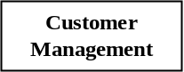
View Details

1st Level Diagram :

Login user
Check User Login Detail

Employee management system
Home page detials
Search Employee Detalis

Employee management
Delete Employee

Update employee
Backup

2nd Level Diagram :
Admin
Employee

Login
Login

New Employee
Employee Details

EmployeeDetails

Employee Detalis

Update Information

View Information

Employee Info.
Bill

Emp. Details

Insert
Update
DATABASE
View
View
Insert
View
Update
Update
Employee
Details
Details
Employee
Employee
details
Details
Employee

USE CASE DIAGRAM

New User Signin

User Login
System Home Page
Add Employee
Fill for Add Emp.
Search Employee
Update Employee
Remove Employee
Exit
Adminn
Employee

A use case is a set of scenarios that describing an interaction between a user and a system. A use case diagram the relationship among actors and use cases.The two main components of a use case diagram are use cases and actors.

Actor Use Case
An actors is represents a user or another system that will interact withthe system you are modeling. A use case is an edkxternal view of the system that represents some action the user might perform in order to complete a task.
Actor and use case description show the details description of interaction between the actor.
And their use case the description enables hdkave a proper under standing of how actor interact.

FLOW CHART
A Flow is a pictorial representation of an algorithm. Programmers often use it as a program-planning tdkool for visually organizing a sequence of steps necessary to solve a problem using computer. It uses boxes of different shapes to denote different type of instructions. The actual instructions are written within these boxes using clear and concise statements. Solid lines dkhaving arrow marks connect these boxes to indicate the flow of operation, that is, the exact sequence in which to execute the instructions. The process of drawing a flowchart for an algorithm is known as flowcharting.
Basic Flowchart Symbols:

Terminal Input/Output

Processing Decision

Flow Line Connectors

Administrative Login Flowchart:

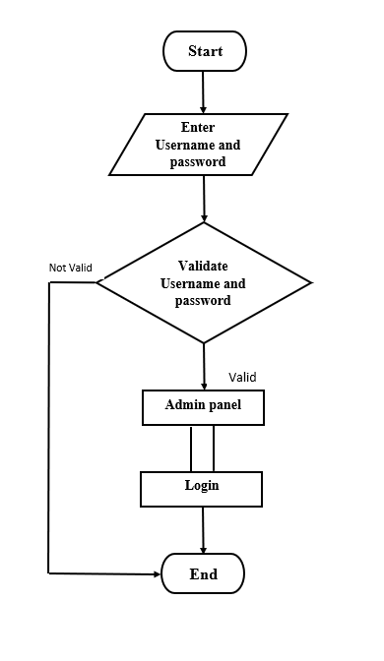

COST ESTIMATION
I have used the COCOMO (Constructive Cost Model) method to estimate the approximate size and cost of this software project. I have performed all the necessary calculations to determine the project's size and cost based on the COCOMO methodology.
COCOMO Method:
To calculate effort E the equation is,
E = 2.4 + (KLOC) 2.46 = 2.4 + (1.85) 2.46 = 6.95 per month
To calculate time period the equation is,
T = 2.5 + (E) 0.38 = 4.27 months
Average 4 months time
Cost Estimation:
Working time estimation is as given,
4 months = 25 days / month = 100 days
4 hr / day = 400 hours
Now, the expenses & cost estimation are given below:

Computer rent = 7900 /-
+ Light Bill Rs. 5 / unit
Worth 320 units = 4900 /-
+ Database design & creation = 6500 /-
+ Coding & Validation = 5200 /-
+ Extra Exp. = 4275/-
Total =28775/-

DATA DICTIONARY & NORMALIZATION
Database Name: ems
Table 1: sign
Column Name | DataType (Size) | Constraints | Remarks
Username | Bigint(12) | A.I, P.K
Password | Varchar(50)
Email | Bigint(10)

Table 2: addemp
Column Name | DataType (Size) | Constraints | Remarks
Name | varchar(30) | A.I, P.K
Fathername | Varchar(30)
Surname | Varchar(30)
Email | Varchr(30)
Designation | Varchr(30)
EmployeeId | Bigint(6)
Birthdate | Varchr(30)
Salary | Bigint(7)
Phoneno | Bigint(10)
Education | Varchr(10)
Adharcardno | Bigint(14)
Address | Varchr(30)

Table3:backup

Column Name | DataType (Size) | Constraints | Remarks
EmployeeId | Bigint(6) | A.I, P.K
Name | Varchar(30)
Phoneno | Bigint(10)
Email | Varchar(30)

SCREEN LAYOUTS

frontpage.java
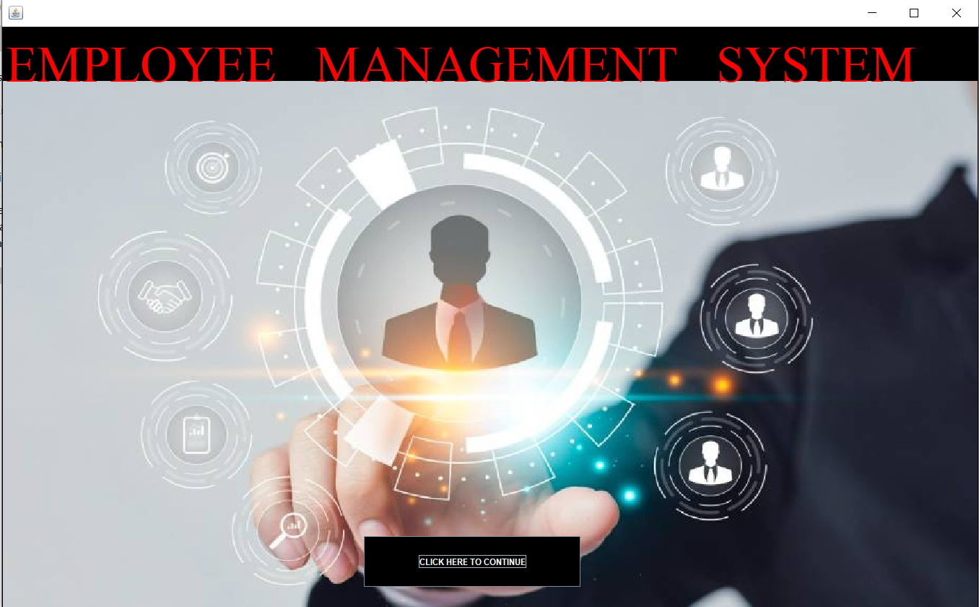

Login.java
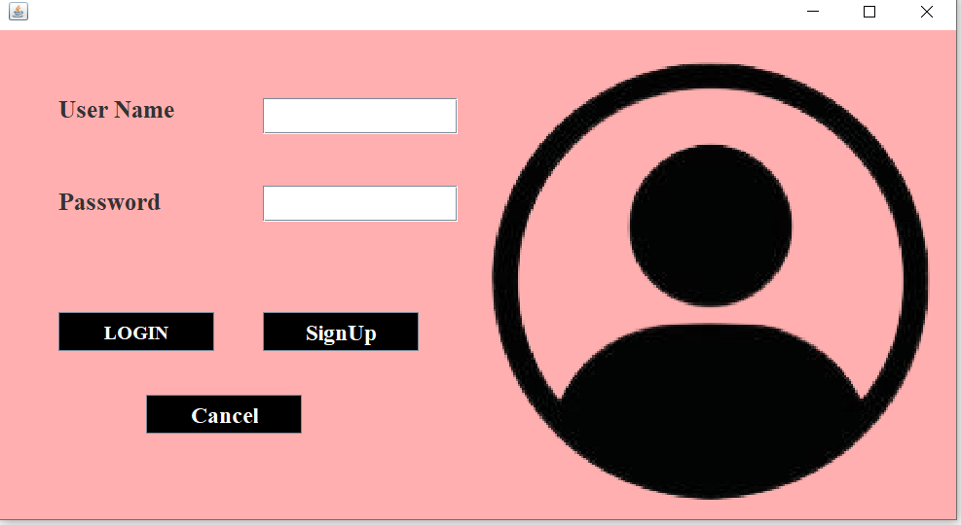
conn c= new conn();
String query="select * from sign where username ='"+luser+"' and password ='"+upassword+"'";
ResultSet rs=c.s.executeQuery(query);
if (rs.next()){
JOptionPane.showMessageDialog(null, "login success....");
setVisible(false);
new home();
}
else{
JOptionPane.showMessageDialog(null, "invalid user name password");
setVisible(true);
username.setText("");
password.setText("");

Sine.java
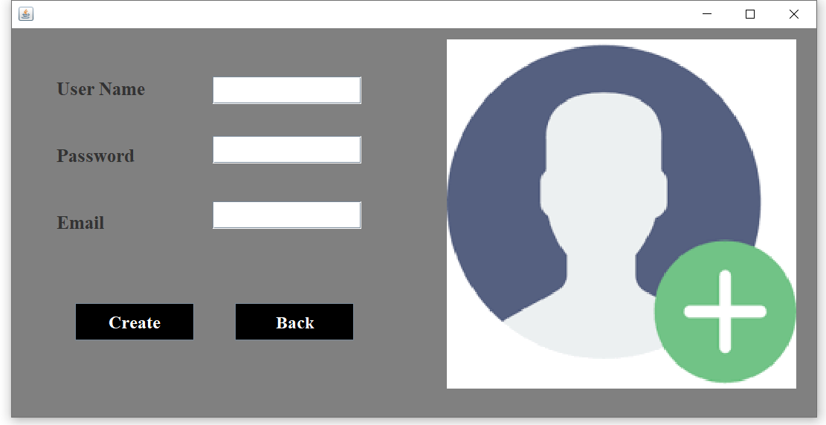

if(ae.getSource()==login)
{
String luser=username.getText();
String upassword=password.getText();
try{
conn c= new conn();
String query="select * from sign where username ='"+luser+"' and password ='"+upassword+"'";
ResultSet rs=c.s.executeQuery(query);
if (rs.next()){
JOptionPane.showMessageDialog(null, "login success....");
setVisible(false);
new home();
}
else{
JOptionPane.showMessageDialog(null, "invalid user name password");
setVisible(true);
username.setText("");
password.setText("");
}
}
String user=username.getText();
String pass=password.getText();
String eml=email.getText();
try{
conn c= new conn();
String query="insert into sign values('"+user+"','"+pass+"','"+eml+"')";
c.s.executeUpdate(query);
JOptionPane.showMessageDialog(null,"Account create successfull");

setVisible(false);
new login();

home.java
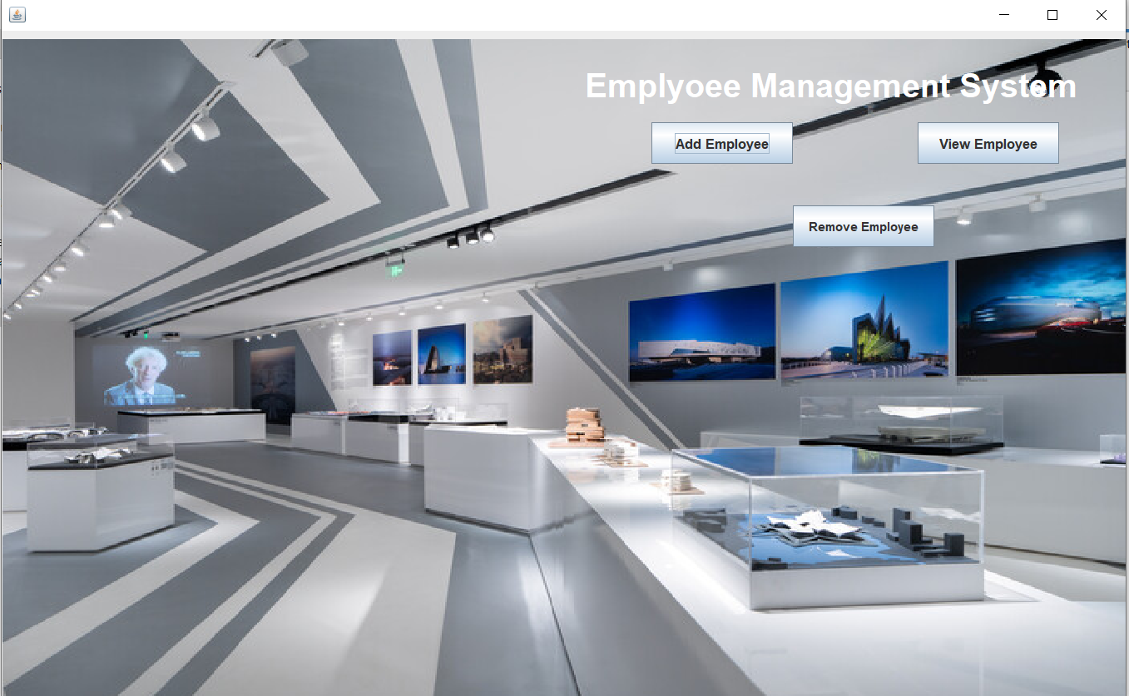

addemp.java
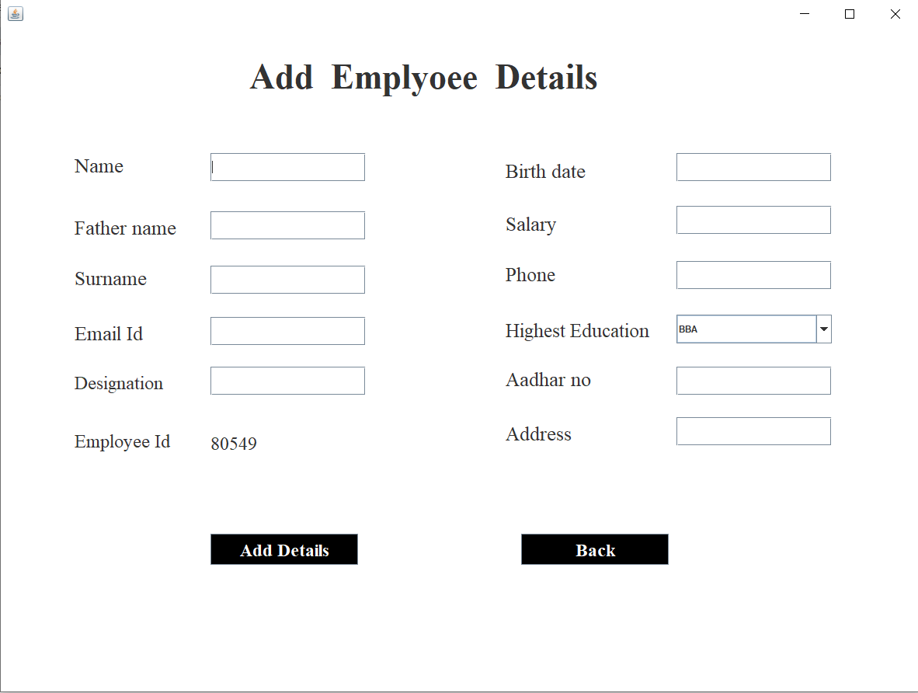
String uname=txtnm.getText();
String father=txtfname.getText();
String surname=txtsurnm.getText();
String Emailid=txteml.getText();
String Designationemp=txtdes.getText();
String Empid=Id.getText();
String dob=txtbd.getText();
String slry=txtslry.getText();
String Phoneno=txtph.getText();
String Edu=(String)acdm.getSelectedItem();
String Adharcard=txtadhar.getText();
String empaddress=txtadr.getText();

try{
conn c= new conn();
String query="insert into addemp values('"+uname+"','"+father+"','"+surname+"','"+Emailid+"','"+Designationemp+"','"+Empid+"','"+dob+"','"+slry+"','"+Phoneno+"','"+Edu+"','"+Adharcard+"','"+empaddress+"')";

c.s.executeUpdate(query);
JOptionPane.showMessageDialog(null,"Employee add successfully ....!!!");
setVisible(false);
new home();
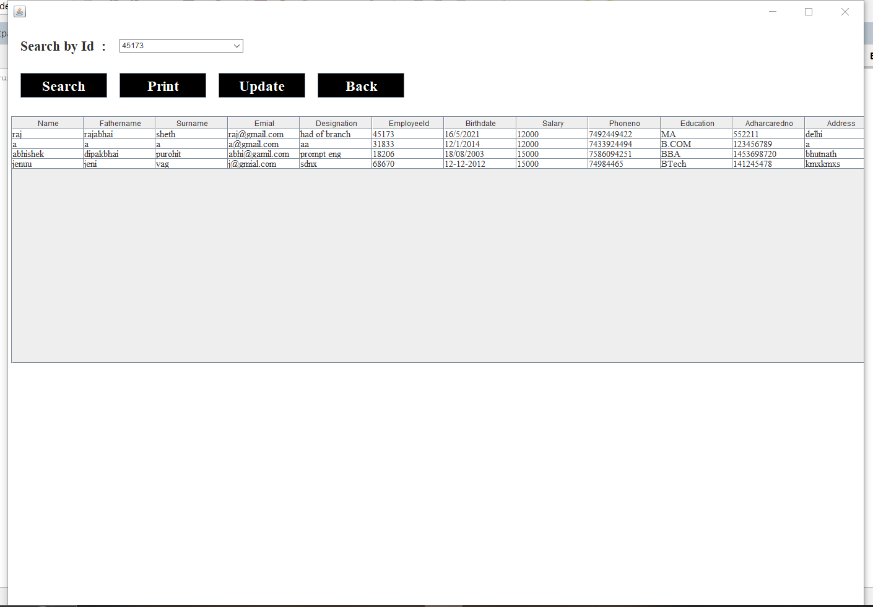

→JTable table;
JScrollPane jsp;
ResultSet rs;
JLabel search;
Choice empid;
conn c=new conn();
rs=c.s.executeQuery("select * from addemp");
while(rs.next())
{

empid.add(rs.getString("EmployeeId"));
}

table=new JTable();
try{
conn c=new conn();
rs=c.s.executeQuery("select * from addemp");
table.setModel(DbUtils.resultSetToTableModel(rs));

jsp= new JScrollPane(table);
jsp.setBounds(5,150,1400,400);
table.setFont(new Font("serif",Font.PLAIN,15));
add(jsp);
String query="select * from addemp where EmployeeId='"+empid.getSelectedItem()+"'";
try{
conn c=new conn();
ResultSet rs=c.s.executeQuery(query);

table.setModel(DbUtils.resultSetToTableModel(rs));

Updateemp.java

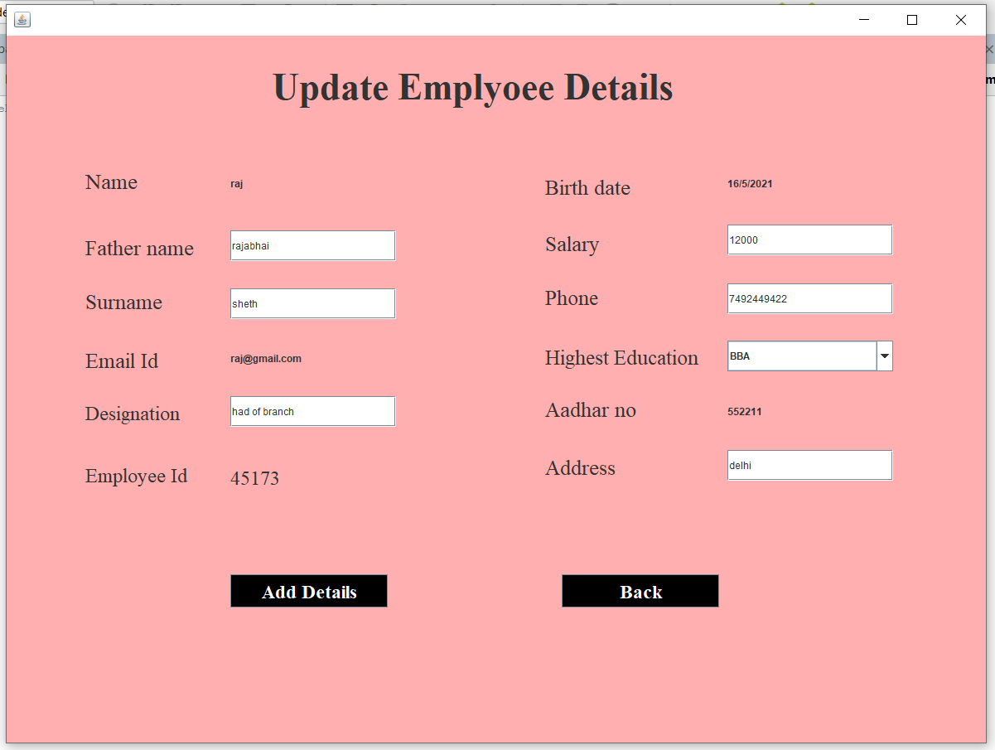

→ try{
conn c= new conn();
String query="select * from addemp where EmployeeId = '"+Empid+"' ";
ResultSet rs=c.s.executeQuery(query);

while(rs.next())
{
lblname.setText(rs.getString("Name"));
txtfname.setText(rs.getString("Fathername"));
txtsurnm.setText(rs.getString("Surname"));
lblemail.setText(rs.getString("Emial"));
txtdes.setText(rs.getString("Designation"));
txtslry.setText(rs.getString("Salary"));
txtph.setText(rs.getString("Phoneno"));
lbladhar.setText(rs.getString("Adharcaredno"));
txtadr.setText(rs.getString("Address"));

Id.setText(rs.getString("EmployeeId"));
lbldob.setText(rs.getString("Birthdate"));

→ String father=txtfname.getText();
String surname=txtsurnm.getText();

String Designationemp=txtdes.getText();

String empid=Id.getText();
String slry=txtslry.getText();
String Phoneno=txtph.getText();
String Edu=(String)acdm.getSelectedItem();

String empaddress=txtadr.getText();

try{
conn c= new conn();
String query="update addemp set Fathername= '"+father+"',Surname= '"+surname+"',Designation= '"+Designationemp+"',Salary= '"+slry+"',Phoneno= '"+Phoneno+"',Education= '"+Edu+"',Address= '"+empaddress+"' where EmployeeId= '"+empid+"'";

c.s.executeUpdate(query);
JOptionPane.showMessageDialog(null," DATA UPDATED successfully ....!!!");
setVisible(false);
new View();

RemoveEmp.java

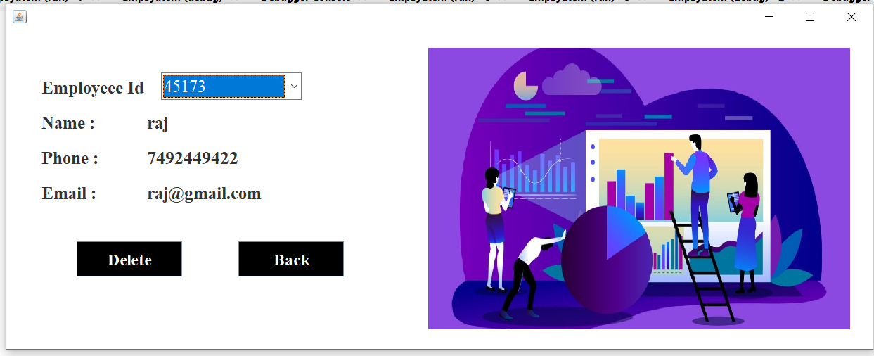

→ conn c= new conn();
String query="select * from addemp where EmployeeId='"+empID.getSelectedItem()+"'";
ResultSet rs=c.s.executeQuery(query);

while(rs.next())
{
lblnm.setText(rs.getString("Name"));
lblphone.setText(rs.getString("Phoneno"));
lblemail.setText(rs.getString("Emial"));

}

→ empID.addItemListener(new ItemListener(){

public void itemStateChanged(ItemEvent e) {

try{

conn c= new conn();
String query="select * from addemp where EmployeeId='"+empID.getSelectedItem()+"'";
ResultSet rs=c.s.executeQuery(query);

while(rs.next())
{
lblnm.setText(rs.getString("Name"));
lblphone.setText(rs.getString("Phoneno"));
lblemail.setText(rs.getString("Emial"));

}

} catch (SQLException ex) {
Logger.getLogger(RemoveEmp.class.getName()).log(Level.SEVERE, null, ex);
}
→try{
conn c= new conn();
String selectedEmpID = empID.getSelectedItem();
String query="delete from addemp where EmployeeId='"+selectedEmpID+"'";
c.s.executeUpdate(query);
JOptionPane.showMessageDialog(null, "Employee deleted Successfully");
setVisible(false);

new View();
setVisible(false);

}
catch(Exception e)
{
e.printStackTrace();
}

SPECIAL UTILITIES
Following are special utilities provided by Electricity Billing System.
- Attractive layout provide to user.
- Easy to find category wise data.
- Provides better way to get Employee information.
- Everyone can free login for his/her signup.
- This system Provide Employee detais
- Manage the information of Employee.

TESTING
Software Development Life Cycle (SDLC) includes a series of production activities one of this is testing.
Testing is a process of executing a program with the intent of finding an error.
Testing is the most important element to be considered for providing quality software and it represents the ultimate review of specification, design and coding.
The success or failure of the software as a system mainly depends on testing. Software Developer spends 40% to 50% of their total development time on testing.
Testing is program consists of providing the program with a set of test inputs and observing if the programs behave as expected. Under which a failure occurs are noted for debugging and correction. The following are some commonly used terms associated with testing.
A test case is the triplet [I.S.O.], where I is the data input to the system, S is the state of the system at which the data is input, and O is the expected output of the system.
Many types of testing techniques are describes as follows:
Unit Testing:
Unit testing is under taken when a module has been coded and successfully reviewed in this section we first discuss the environment needed to perform unit testing.
Here in this project we test each and every module and forms of software application individually when it is completely coded.
There are some methods for unit testing are as follows:
Black Box Testing:
A black-box test examines some fundamental aspect of a system with little regard for the internal logical structure of the software.
When computer software is considered, black-box testing alludes to tests that are conducted at the software interface. Although they are designed to uncover errors, black-box tests are used to demonstrate that software functions are operational, that input is properly accepted and output is correctly produced, and that the integrity of external information (e.g., a database) is maintained.
Black-box testing, also called Behaviour testing, focuses on the functional requirements of the software. That is, Black-box testing enables the software engineer to derive sets of input conditions that will fully exercise all functional requirements for a program.
In my system Black-box testing attempts to find errors in the following categories:
- Incorrect or missing functions.
- Interface error.
- Error in data structures or external data base access.
- Behaviour or performance error.
- Initialization and termination errors.
Basically, in my system, Black-box tests are designed to make my system an error free system. I used validity test in each form.
White Box Testing:
In this technique, the close examination of the logical parts through the software are tested by cases that exercise species sets of condition or loops.
All logic part of the software checked once.
Erro that can be corrected using this technique are typegraphical errors.logiacl expressions whice should be executed once may be getting ececuted more than once and error resulting by using wrong controls and loops.
When the box testing tests all the independent part within a module a logical decisions on their true and the false side are exercised, all loop, and bounds within their operational bounds were exercised and internal data structure to ensure their validity were exercised once.
White box testing to the admin error.
Functional Validity Testing:
My project system is well functional. Each and every step has tested during design phase of software development. I used date field with a SimpleDateFormat class of java, so this command checks every entry for date format. I used on KeyReleased event with conditional statements to fill the only numeric data. One can’t input string data in place of numeric data.
Integration Testing:
The primary objectives of the integration testing is to test the module interface in order to ensure that there are no error in parameter passing when one module invokes another module.
During integration testing differentdk module of system as per integration plane the integration plan specify the steps and the order in which module are combine to realize the full system.
Following are the integration testing Methods & Approaches:
- Big bang approach
- Top down approach
- Bottom up approach
- Mixed approach
System Testing:
In the system testing the whole application is tested and the error and failure possibility is carried out in it.
- Alpha testing
- Beta testing
- Acceptance testing
- Performance testing
- Error seeding
Testing is a process of executing a program with the intent of finding an error.
A good test case is one that as a high probability of finding an as yet in discovered error.
Software testing is a critical element of software quality assurance and represents the ultimate review of specification, design and coding. the increasing visibility of software as a system element and the attendant “Cost” associated with a software failure are motivating forces for well – planned, thorough testing. It is not unusual for a software development organization to expend between 30 to 40 percent of total project effort on testing. In the extreme, testing of human-rated software can cost three to five times as much as all other software engineering activities combined.
There are several testing techniques but we have been focused to White box testing techniques. As well as this software is concerns we have test all required testing of this site.
Testcase
VALIDATION CHECKS TEST CASES:
A Test case is a set of conditions or variable under which a tester will determine whether a system satisfy requirement or works correctly.
The process of developing test case can also help to find the problem in requirement or design of an application.
A test case can have the following elements, not however that normally a test management tool is used by companies by the tool used

No | Name | Description
1. | Test Suit ID | The ID of the test suit, to which this test case belongs.
2. | Test Case ID | The ID of the test case.
3. | Expected Result | The expected result of the test. Actual Result: The actual result of the test, to filled after executing the test case.
4. | Created By | The name of the author of the test case.
5. | Executed By | The name of the person who executing the test cases
6. | Pass/Fail | The result in "Pass" or "Fail" according to the test, when the expected result and the actual result is same then the result is "pass" else result is "fail".
7. | Remark | Any comment on the test case or test execution.

IMPLEMENTATION
Implementation refers to the entire effort associated with a new system. The implementation of a web application involves longer term issues after the system hasbeen designed and installed. Implementation is a part of the design of a web application, and is an organizational change process. It is a part of the process that begins with the very first idea for a web application has been successfully integrated with the operations of the organization. We expect most of the implementation to be concerned with behavioral phenomena since people are expected to change their information processing activities.
The implementation is processed from review and reports from developer coverthe following areas:
• Good working conditions.
• Useful for gathering information.
• Update website easily.
• Attractive layouts.
• Working for as per requirements
BIBLIOGRAPHY
There are some study materials which is used by me to develop my software system, which are as follows:

Websites:
- www.programmingtutorials.com
- www.javatpoint.com
- www.W3resource.com
- www.geeksforgeeks.com
I am mostly use or preferred web site and you tube because that platforms are provide large amount of information what you want and also number of programmes related to query and project.

